**Welcome page :**

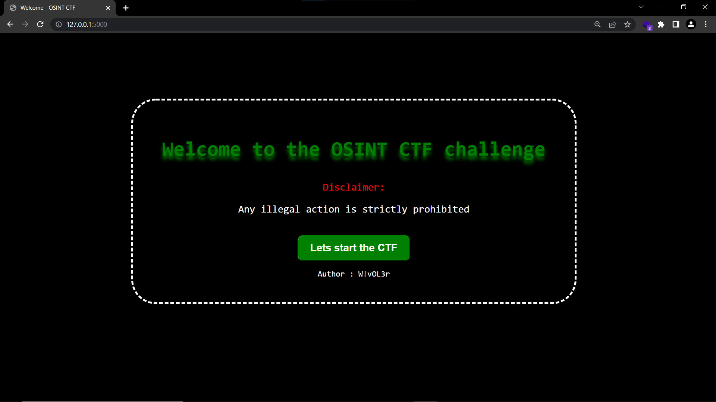

**Level 1 : Find the place**

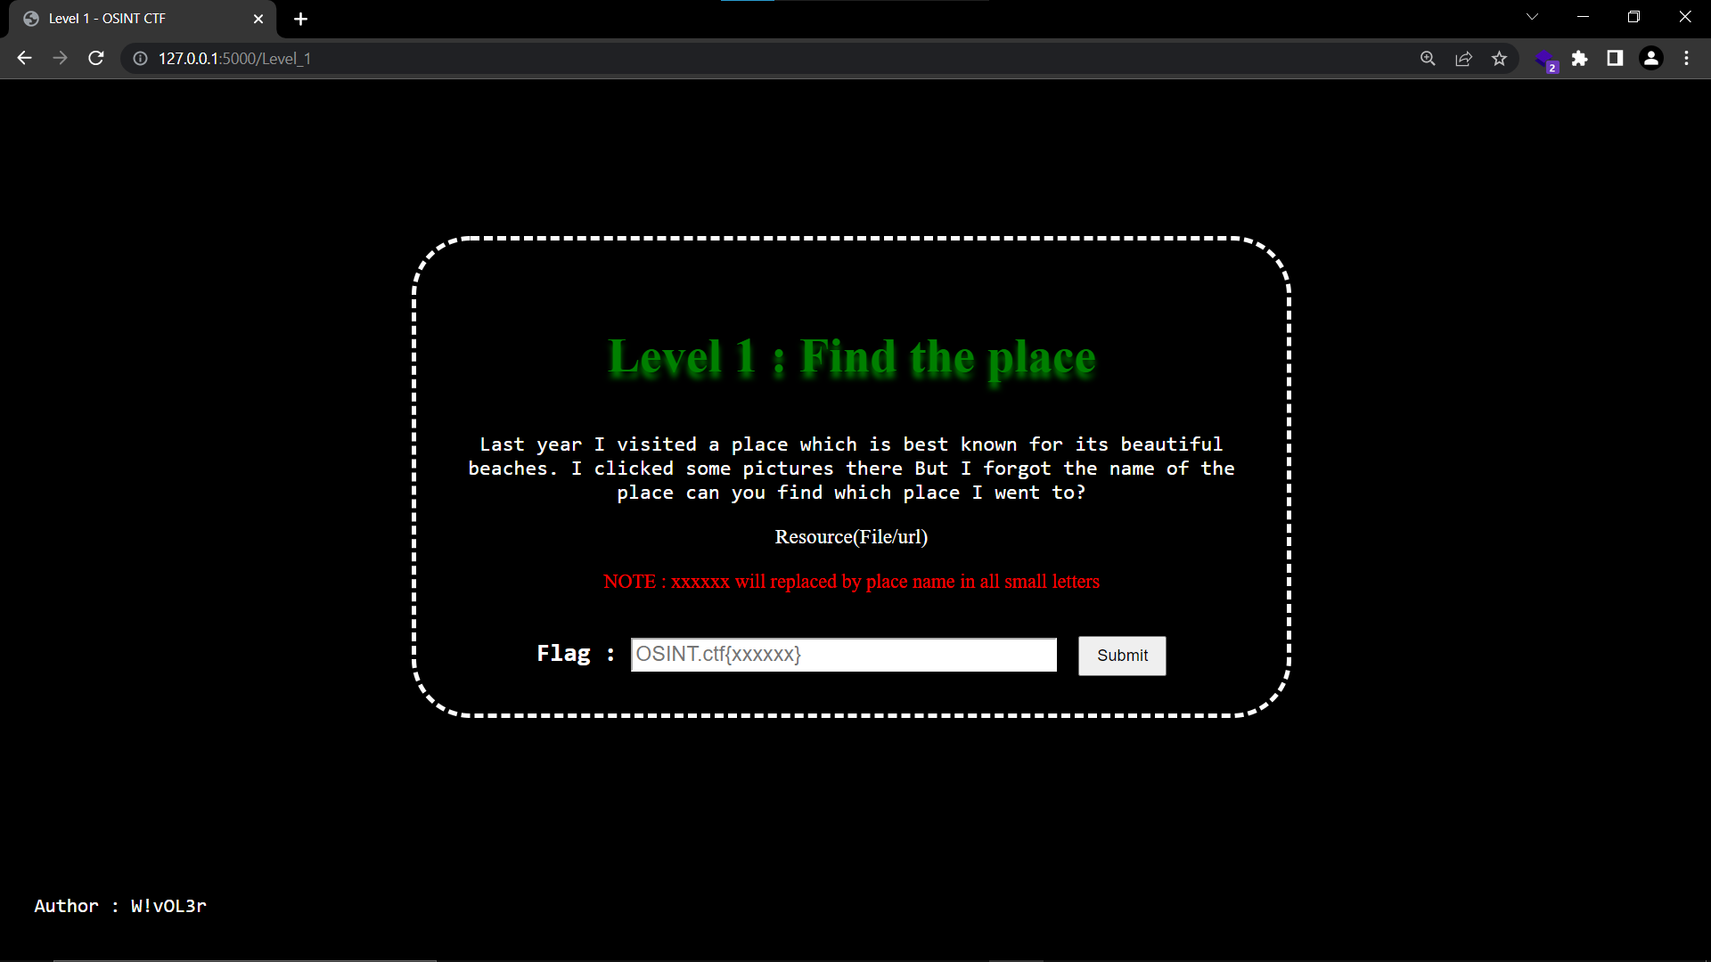

As we see the image is provided and told that the image is about the beautiful beaches and asked to find the name of the place shown in the image . Lets check the image first.

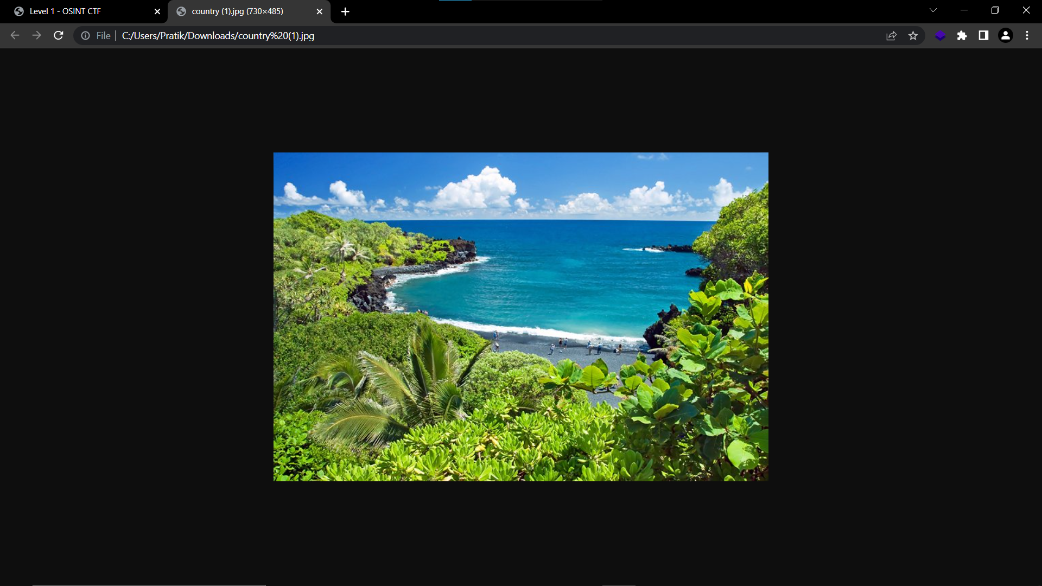

Now will try do find the image using the google lens

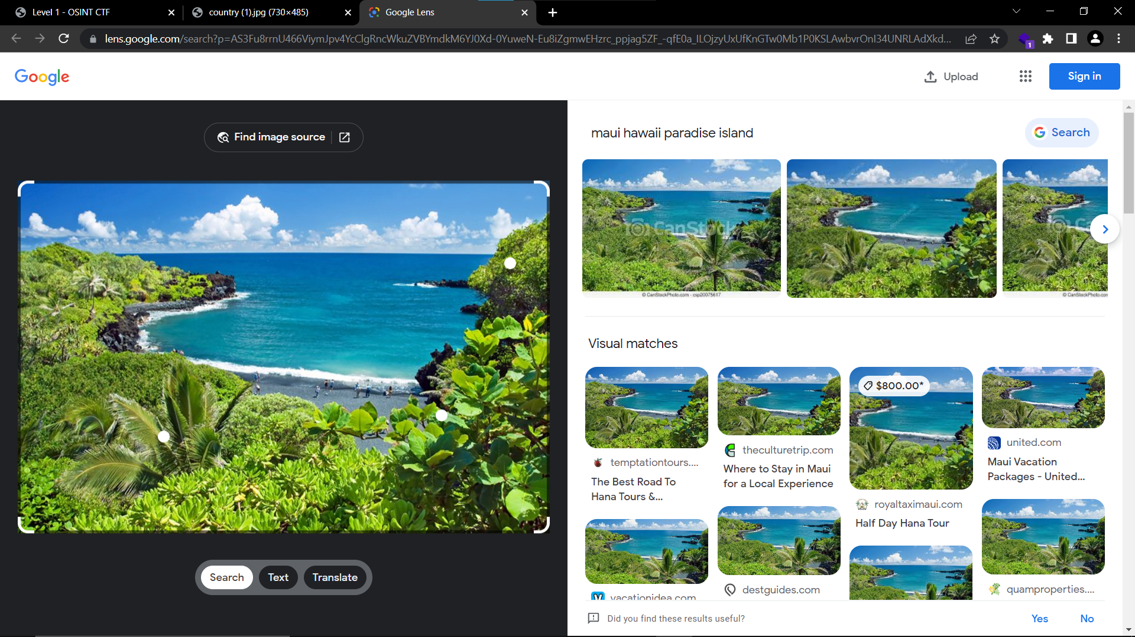

And boom we found our first flag , the name of place is Hawaii

Flag : OSINT.ctf{Hawaii}

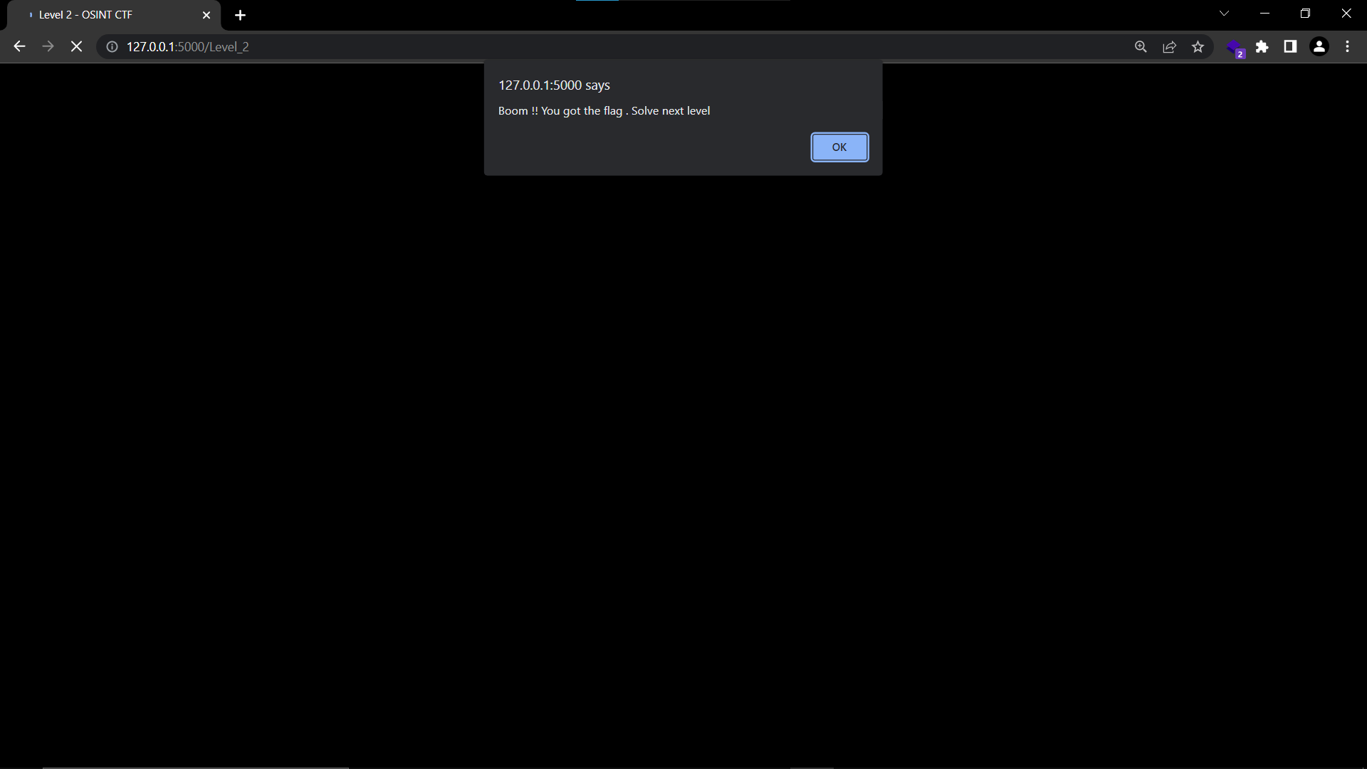

**Level 2 : Orbiter**

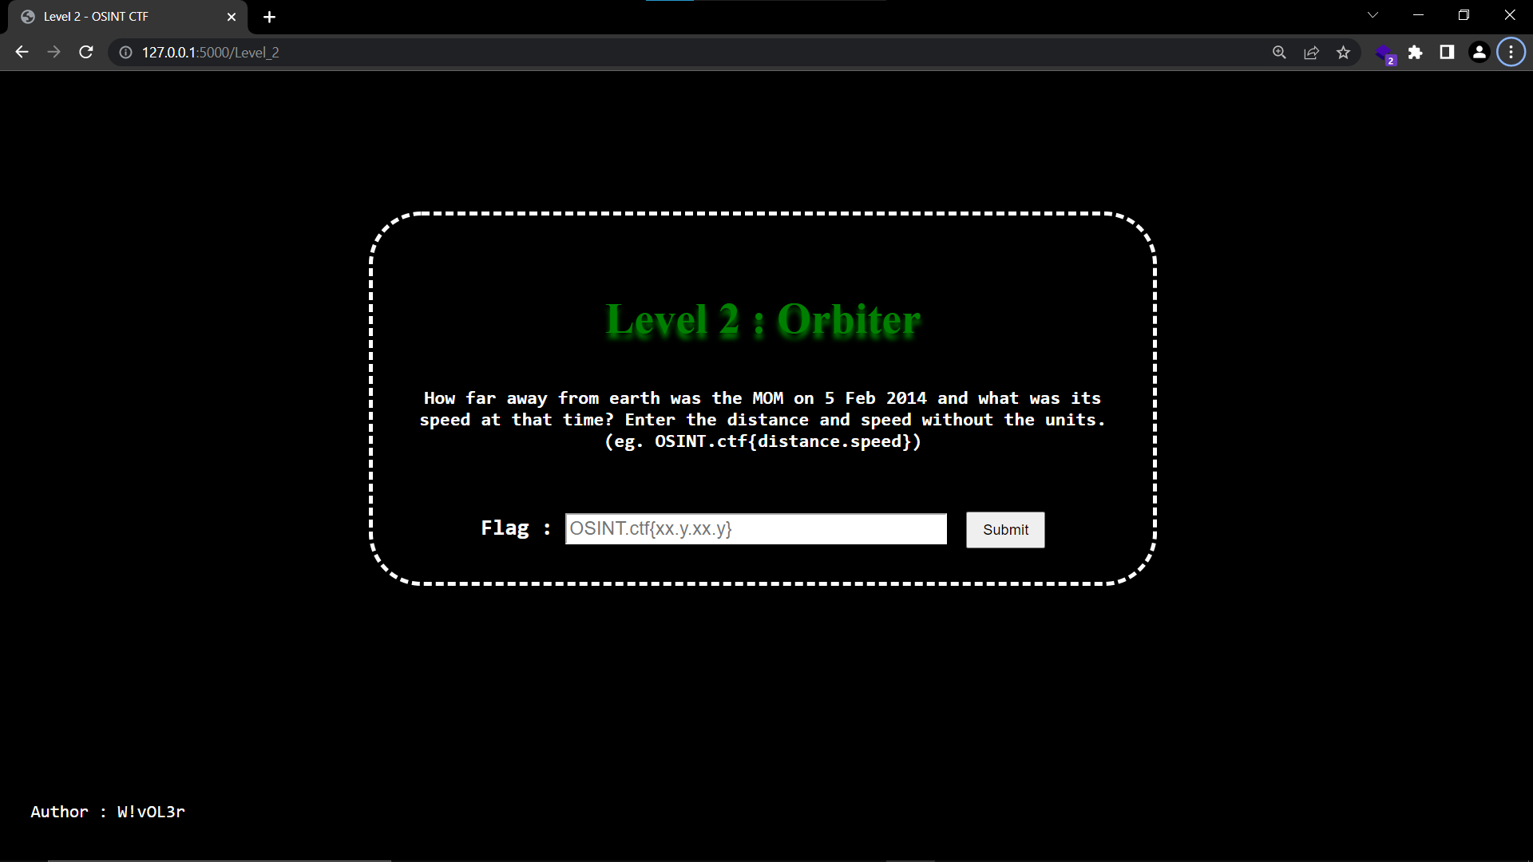

As in this distance between the MOM and earth is asked MOM may be some satellite , spacecraft or may start or planet name , first we have to find what MOM actually is.

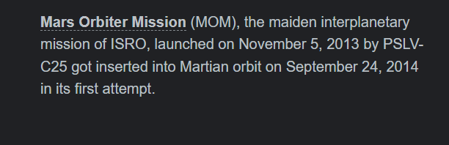

So on doing so we found that MOM is an orbiter mission by ISRO and found the full form of MOM.

Then we find the distance of MOM on given date , no any data found , but one key point reflected that MOM is also called as Mangalyan , let check by this name

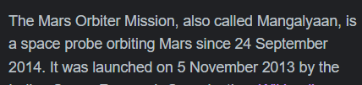

After reading some articles found one article matching the distance question asked

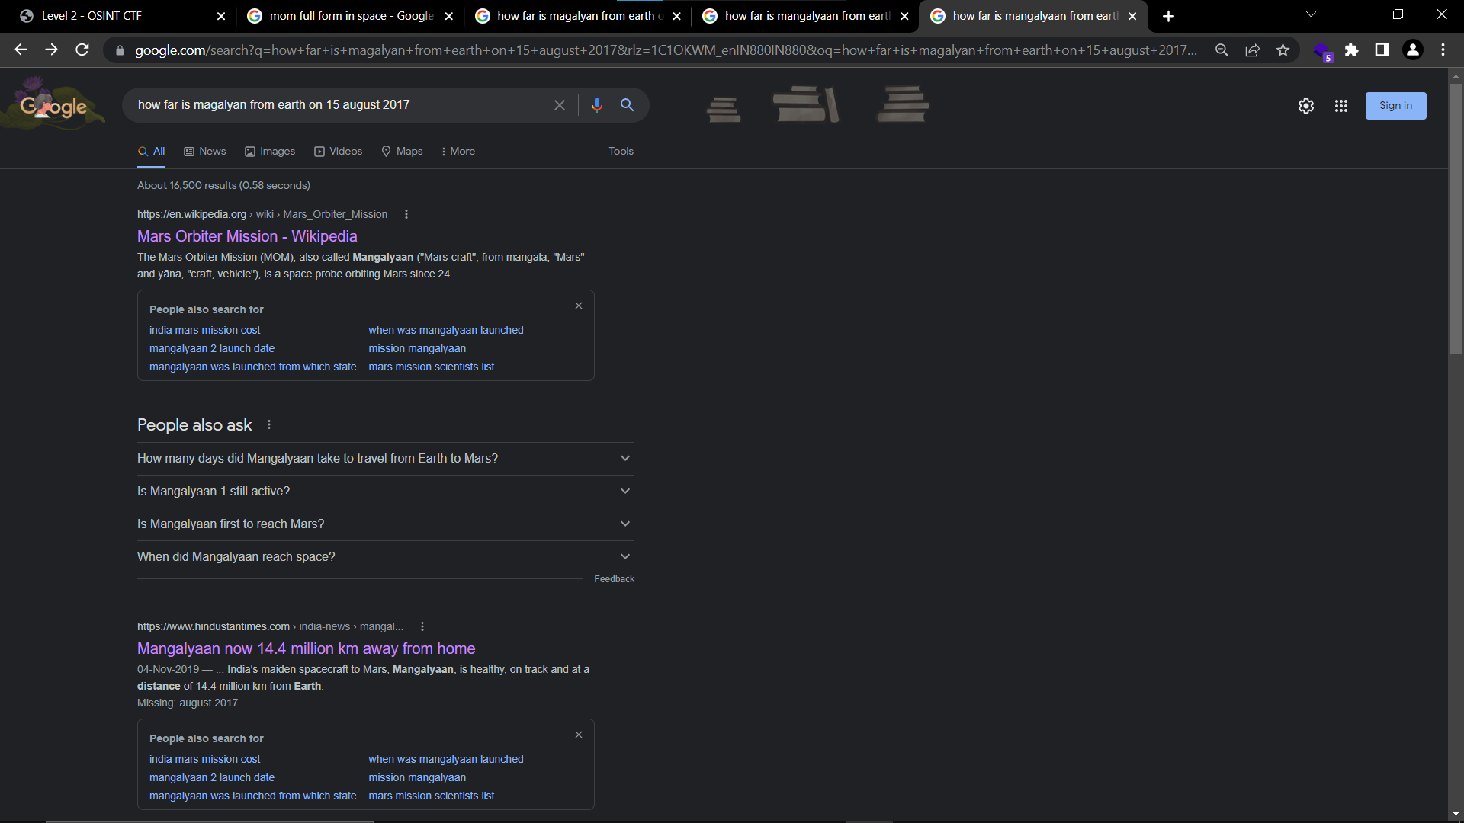

After opening the article Boom we found both the distance and speed of MOM on 5 feb 2014

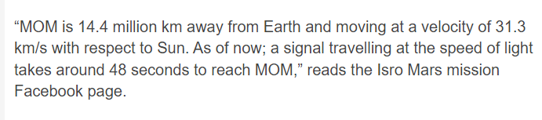

So the flag for level 2 is OSINT.ctf{14.4.31.3}

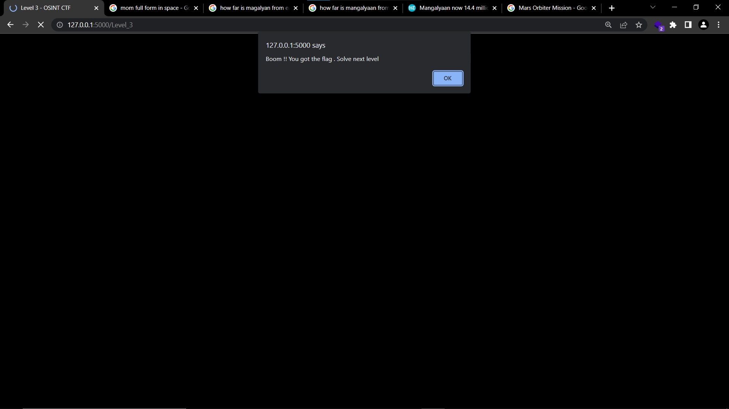

**Level 3 : Find me**

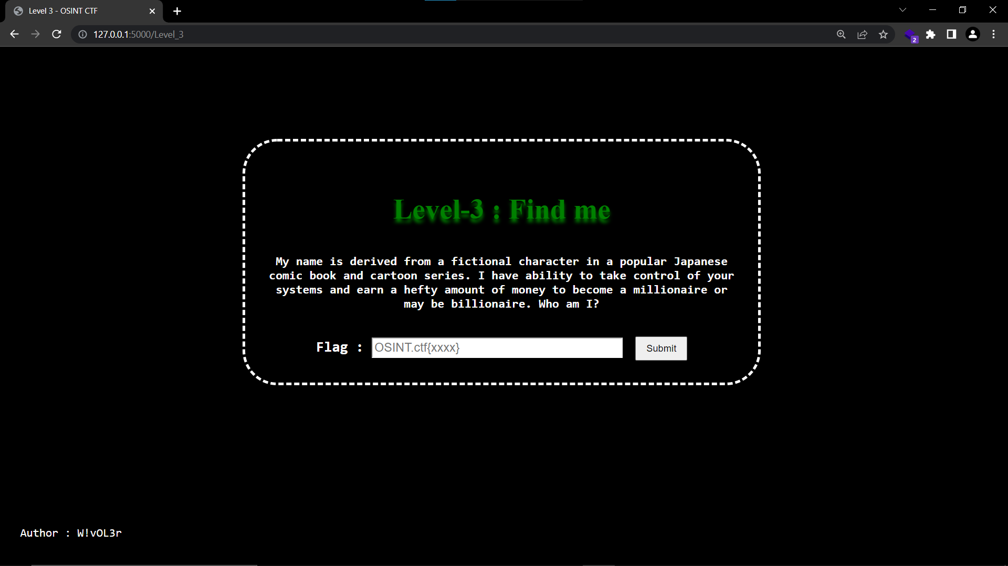

As per the question asked , if we see carefully

*“ I have ability to take control of your systems and earn a hefty amount of money to become a millionaire or may be billionaire “*

It is somehow hinting towards the ransomware , because ransomware takes control of the systems and asks for a hefty amount of money in exchange for all the data they locked .

So let try to find by google

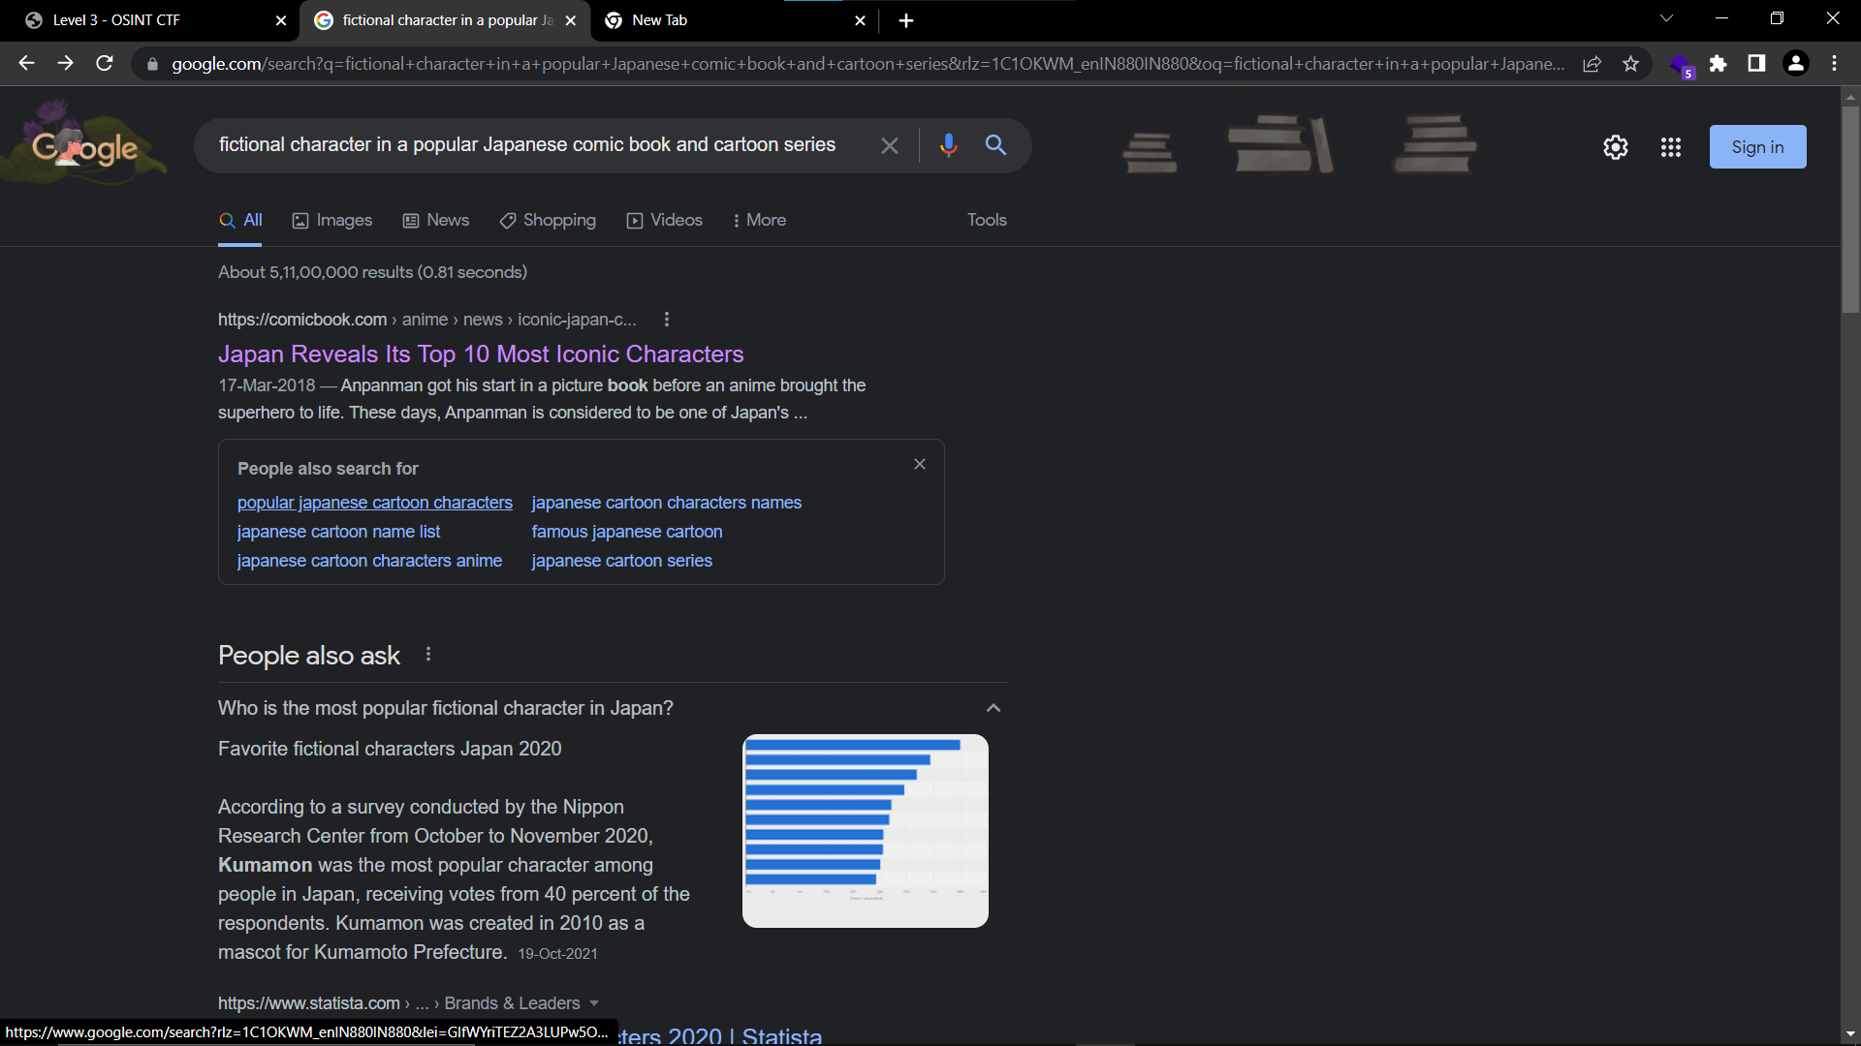

Searching the character doesn't give direct results about the name as there may be more than one .

After searching for

*“ransomware name derived from fictional character in a popular Japanese comic book and cartoon series”*

Some interesting name highlighted called Ryuk ransomware

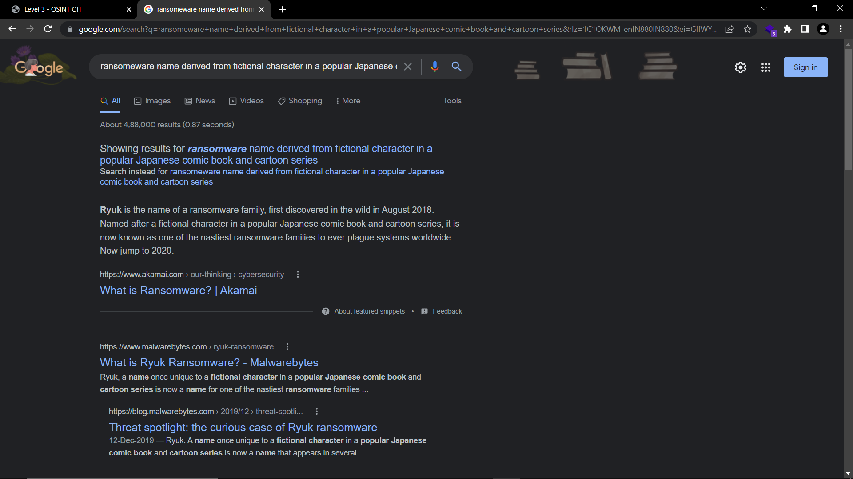

Let's try to check how its name is derived



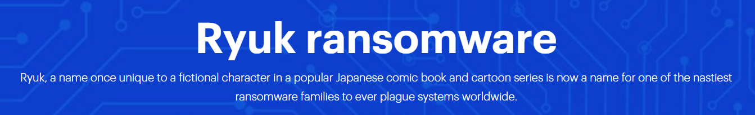

And yes it's matching with the name asked and is exactly matching with the number of characters in OSINT.ctf{xxxx}

Let’s check whether it's right or not. So the flag may be now OSINT.ctf{Ryuk}

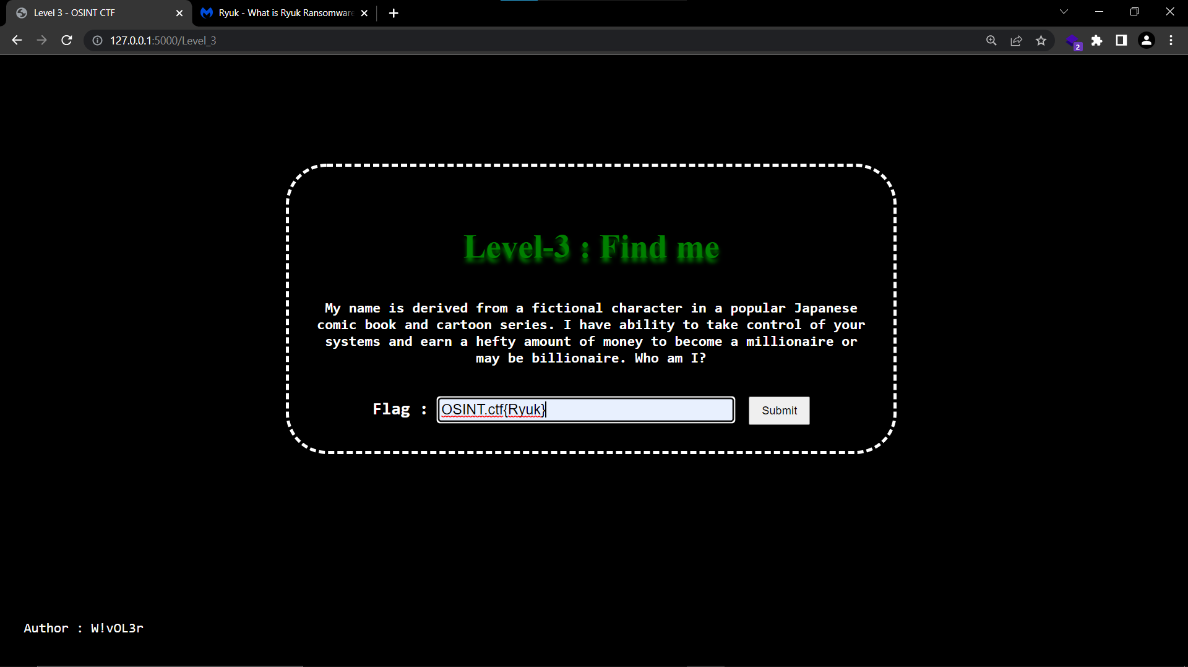

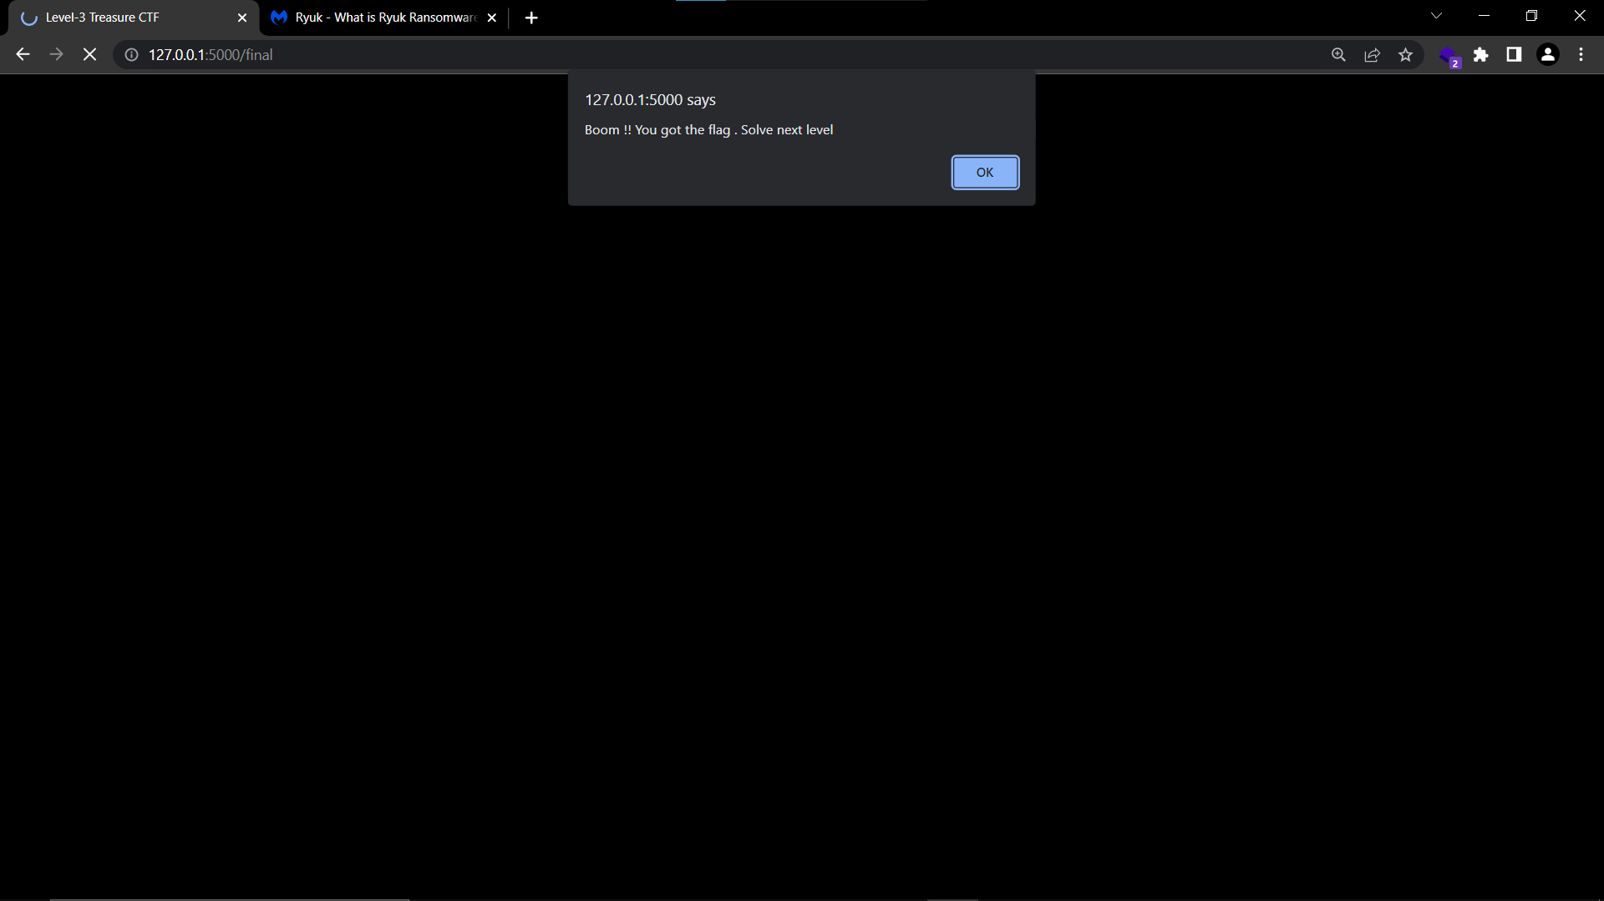

Boom we guessed it right , so the flag is OSINT.ctf{Ryuk}

**Final : OSINT**

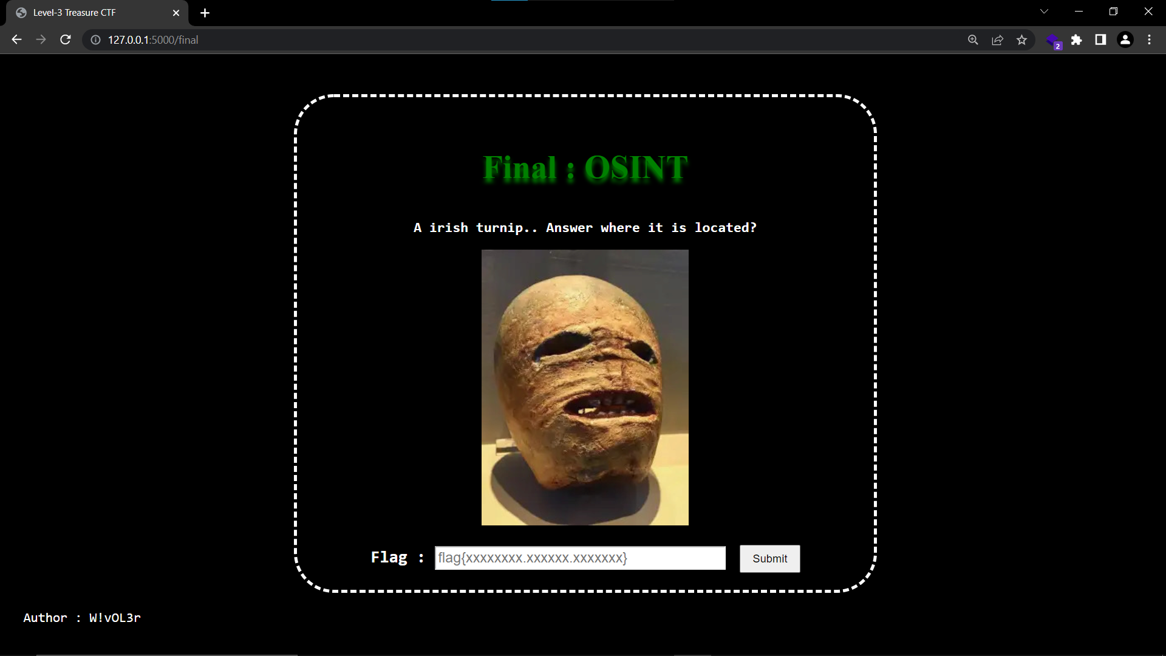

The image is given and given name is *“A irish turnip..”*  , so lets us try to find by the name given

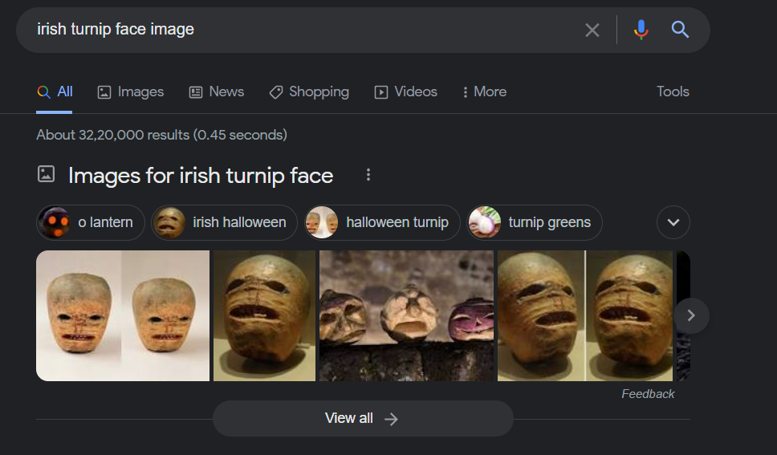

Found some similar faces , lets us find what actually it is

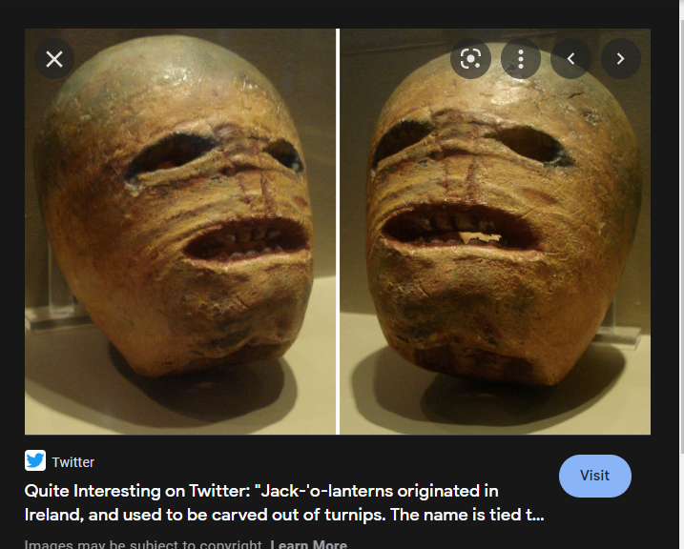

The search result shows that it is located in Ireland but flag pattern is flag{xxxxxxxx.xxxxxx.xxxxxxx} , which means it contains 3 words and last word pattern matching with the name Ireland , it may be the one word.

Lets us find more about this

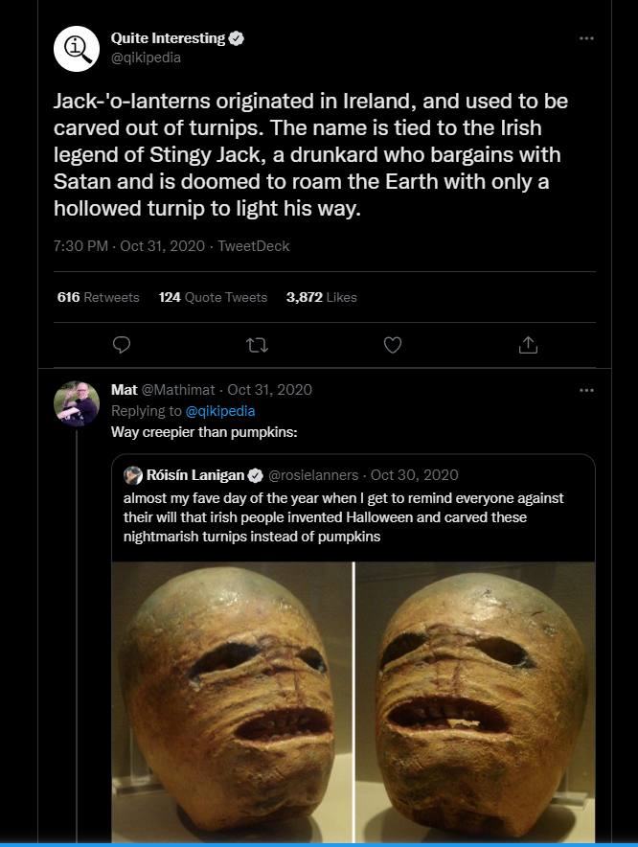



The result on twitter shows its like a Halloween pumpkin carved in turnips .

Since it is the final one it is kind of tricky to exactly find the flag as it contains the 3 words may be.

But since it seems like ancient things made many years ago and it may be kept in the museum or like that lets check if its kept in museum or like that.

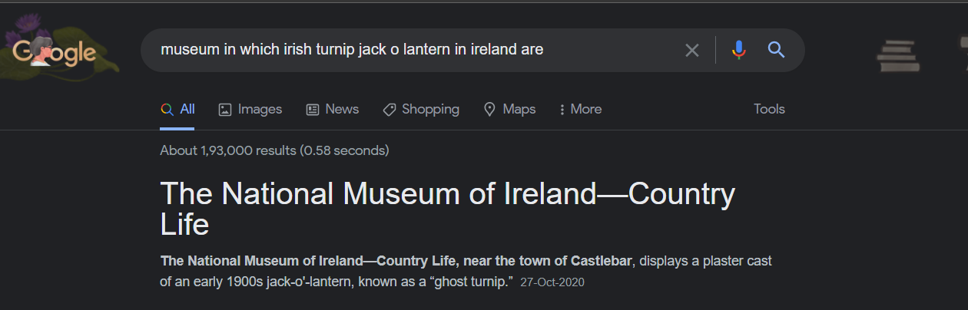

Found something the museum in which is is kept it is somehow matches the flag pattern

If we skip the *“of”*  the name will be “national museum ireland” so it may be

OSINT.ctf{national.museum.ireland}

And boom we found it correctly , so the flag is OSINT.ctf{national.museum.ireland}

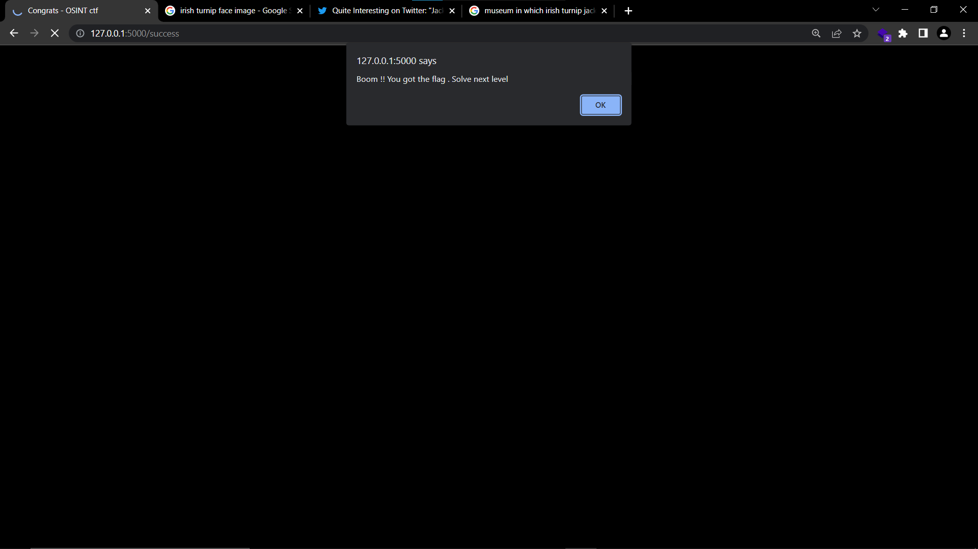

Finally all levels of CTF are cleared

